UNIVERSITY OF HERTFORDSHIRE
School of Physics, Engineering and Computer Science

MSc Data Science Project
7PAM2002
Department of Physics, Astronomy and Mathematics

Data Science FINAL PROJECT REPORT

Project Title: Solar Energy Production Forecasting Using Machine Learning

Student Name and SRN: Uma Chandra Sekhar Adavi
Supervisor: Pedro Carrilho
Date Submitted: March 2026
Word Count: Approximately 4141 words (excluding references and appendices)
GitHub Link: https://github.com/Adavi2000/Solar-power-forecasting-.git


Table of Contents
Declaration Statement 4
Abstract 5
Chapter 1 — Introduction 6
Chapter 2 — Background and Literature Review 6
Chapter 3 — Dataset and Exploratory Data Analysis 7
3.1 Data Sources 7
3.2 Data Preprocessing 8
3.3 Exploratory Data Analysis 9
Chapter 4 — Ethical Considerations 10
Chapter 5 — Methodology 11
5.1 Feature Engineering and Selection 11
5.2 Task Definition — Prediction vs Forecasting 11
5.3 Train/Test Split 11
5.4 Model 1 — Random Forest Regressor with GridSearchCV 12
5.5 Model 2 — LSTM Network 12
5.6 Baseline and Evaluation Metrics 12
Chapter 6 — Results 13
6.1 Random Forest — Test Set Performance 13
6.2 Feature Importance 14
6.3 LSTM — Test Set Performance 15
6.4 Model Comparison 16
6.5 Generalisation to Plant 2 16
Chapter 7 — Analysis and Discussion 16
7.1 Why Random Forest Outperformed LSTM 17
7.2 Irradiation as Dominant Predictor 17
7.3 Limitations 17
7.4 Future Work 17
Chapter 8 — Reproducibility 18
Chapter 9 — Conclusion 18
References 19
Appendix A — Random Forest Hyperparameter Grid 19
Appendix B — Python Environment 20
Appendix C — Core Notebook Code 20
C.1 — Imports and Configuration (Cell 2) 20
C.2 — Preprocessing Pipeline (Cell 6) 21
C.3 — Feature Selection (Cell 20) 22
C.4 — Train/Test Split (Cells 22–23) 22
C.5 — GridSearchCV — Random Forest (Cells 25–26) 22
C.6 — LSTM Architecture (Cells 36–39) — Exact Notebook Architecture 23
C.7 — LSTM Predictions and Metrics (Cell 41) 24
C.8 — Save Results (Cell 51) 24

Declaration Statement
This report is submitted in partial fulfilment of the requirement for the degree of Master of Science in Data Science at the University of Hertfordshire.
I have read the detailed guidance to students on academic integrity, misconduct and plagiarism information provided in the programme handbook and on the University website. I understand what is expected of me in relation to academic integrity and that the University takes this seriously.
I certify that the work submitted is my own and that any material derived or quoted from published or unpublished works of others has been duly acknowledged. I did not use generative AI tools to produce any of the work submitted.
I did not use human participants in my MSc Project.
I hereby give permission for the report to be made available on module websites provided the source is acknowledged.

Student Name printed: Uma Chandra Sekhar Adavi
Student Name signature: Uma Chandra Sekhar Adavi
Student SRN number: 23095401

UNIVERSITY OF HERTFORDSHIRE
SCHOOL OF PHYSICS, ENGINEERING AND COMPUTER SCIENCE

Abstract
Solar energy output is an essential factor to be correctly forecasted to make efficient energy management and grid stability planning. This paper constructs and analyzes machine learning algorithms to forecast the AC power output of 2 photovoltaic (PV) plants in India. The raw data provided by Kaggle consists of around 300,000 records at inverter level during a 34-day operational period (15 May -17 June 2020) with 15-minute intervals of 22 inverters per plant. Upon aggregation between inverters, each plant generates approximately 3259 time-series samples to be applied in the modelling process.
Two modelling strategies are used, which are a Random Forest Regressor with hyperparameter optimization via Timeseries Split cross-validation and a Long Short-Term Memory (LSTM) network with early stopping. An 80/20 split of time makes sure that there is no leakage of data. Random Forest model has better performance (RMSE = 521.50 kW, MAE = 245.95 kW, R² = 0.9957) compared to LSTM (RMSE = 2,333.42 kW, MAE = 1,291.49 kW, R² = 0.9183). The fact that solar irradiation is the most important predictive variable is supported by permutation importance analysis which is in line with photovoltaic physics. The authors conclude that under strong feature-target correlation conditions, ensemble tree-based techniques offer robust power prediction with interpretable results.

Chapter 1 — Introduction
Solar energy is one of the critical elements in the quest by the world to move towards sustainable energy systems. With the increased apprehensions on climate change and the dwindling fossil fuel reserves, the photovoltaic (PV) systems have come out as the main source of renewable energy. Solar power generation is, however, non-deterministic, and is subject to weather, time of the day and season and this poses a problem to grid integration and energy planning.
Predictive modelling of solar energy production allows grid operators and facility managers to predict the changes in supply and optimize the dispatch decision. The recent advances in machine learning bring significant opportunities to make predictions more accurate than it is possible with any traditional statistical technique, especially when non-linear feature interactions are present.
In this research, the authors plan to develop, deploy, and compare machine learning models that can forecast solar energy production using past meteorological and operational data. Two architectures are explored: a Random Forest Regressor - an ensemble tree-based algorithm that has high interpretability and a Long Short-Term Memory (LSTM) network that can model sequential data.
Research Question: To what extent can machine learning models accurately predict solar energy production using contemporaneous meteorological and operational data from photovoltaic installations?

Project Objectives:
Processes Data Collection and Preparation: Obtain and process solar plant data, temporal aggregate, use a time-based interpolation model on missing data points, and design cyclic time processes.
Exploratory Data Analysis: Measure and describe zero -power periods, analyze irradiation-power correlations, and calculate feature correlations in both plants.
Model Implementation: Build the Random Forest and LSTM models using time-based train test splits to avoid the leakage of data.
Hyperparameter Optimization: GridSearchCV TimeSeriesSplit cross-validation Hyperparameter search of systematic Random Forests across 81 parameter combinations.
Examination and Analysis: Compare models on RMSE, MAE, and R², and use permutation importance to eliminate significant predictors.

Chapter 2 — Background and Literature Review
Using machine learning to predict solar energy appears in the recent literature in a comprehensive manner. The study by (Antonanzas et al., 2016) aims to give a thorough overview of the photovoltaic forecasting strategies, the significance of meteorological inputs in forecasting, and the effectiveness of machine learning in comparison with the physical models in the short-term prediction tasks.
(Voyant et al., 2017) compared different machine learning methods to predict solar radiation and found their neural networks to have competitive results in case there is enough historical data. They have however pointed out that simpler ensemble models can work better than deep learning in a situation where the feature space is clear and correlated with the target variable a fact that is specifically of relevance to the findings of the current research.
Formalized by (Breiman, 2001), random Forest combines the outputs of many decision trees to reduce variance and eliminate overfitting. It is well adapted to the solar forecasting tasks due to its resistance against the irrelevancy of features and ability to naturally deal with non-linear relationships.
The Long Short-Term Memory networks (Hochreiter and Schmidhuber, 1997)were created to attain long-range temporal dependencies in the sequential data by use of the so-called gating mechanism. They have demonstrated their potential in renewable energy application in scenarios where temporal autocorrelation is high but may be hard to converge in data with sharp weather-driven variations (Wan et al., 2015)
In a thorough survey of PV solar power prediction methods, (Ahmed et al., 2020) discovered that ensemble tree forecasting models often outperform LSTM based forecasting models unless the datasets have high feature-target correlation, especially their relationships with irradiation (the correlation of irradiation to power). This research puts its results into context in relation to this literature.

Chapter 3 — Dataset and Exploratory Data Analysis

3.1 Data Sources
The data that will be used in this paper is the publicly available Solar Power Generation Data on Kaggle (Solar Power Generation Data, no date). It is a collection of historical data on solar power generation, as well as the measurements of meteorological sensors of 2 photovoltaic (PV) plants in India (Plant 1 and Plant 2). It has operational data at inverter level, AC power, DC power, and energy yield and environmental variables, e.g. solar irradiation, ambient temperature, and module temperature.
The uncoded data will consist of approximately 300000 inverter-level measurements at 15-minute intervals on 34 days (15 May-17 June 2020) of 22 inverters per plant. To simplify the modelling process, the data between the inverters was aggregated, i.e. each single timeline was a record of the total power output of the plant and the average conditions outside. When aggregated, each plant has approximately 3,259 time-series observations which are used to test and train the model.
The plants are also similar in their structure being columns, which enables analysis of cross-plant generalization. The data sets exhibit different diurnal distributions of solar generation in which the power generation during the day increases and at night, it falls to zero. Since it contains a significant number of times resolved variables and operational variables alongside environmental variables, the dataset can contribute immensely to the machine learning to forecast solar power. The dataset does not contain any personal information that can identify a particular person and, in this way, the ethical criteria of the conducting of research are maintained.
Table 1: Dataset Variable Descriptions
Variable | Type | Description
DATE_TIME | Datetime | Timestamp of measurement (15-minute intervals)
AC_POWER | Numeric (kW) | AC electricity output — target variable
DC_POWER | Numeric (kW) | DC power generated by PV panels before inversion
IRRADIATION | Numeric (kW/m²) | Solar radiation received by the panels
AMBIENT_TEMPERATURE | Numeric (°C) | Surrounding air temperature
MODULE_TEMPERATURE | Numeric (°C) | PV panel surface temperature

This dataset is appropriate in predicting solar power due to several reasons; the irradiation is a direct controller of energy conversion efficiency; temperature variables control the panel performance; and the resolution of 15 minutes allows predicting within a day. The high value of the irradiation-to-AC power correlation (r =0.99, Plant 1) offers a solid physical foundation to machine learning model.

3.2 Data Preprocessing
All preprocessing was applied to raw inverter-level data before any modelling step, preventing information leakage from the test period into training. The pipeline follows seven ordered stages:
- Parse DATE_TIME to datetime64 format; sort each plant chronologically by DATE_TIME and SOURCE_KEY.
- Remove exact duplicate records (identical DATE_TIME and SOURCE_KEY combinations).
- Apply time-based linear interpolation for missing values in numeric predictor columns within each inverter group.
- Drop rows where AC_POWER (target) is NaN and cannot be imputed.
- Aggregate across inverters per timestamp: sum AC_POWER and DC_POWER; compute means of weather variables.
- Assert that zero missing values remain in the aggregated dataset.
- Engineer cyclic time features: HOUR_SIN/COS = sin/cos(2π·hour/24); DOY_SIN/COS = sin/cos(2π·DoY/365).
There are no data errors of 0 AC power values, which represent about 47 percent of rows in both plants, but no data error is physically possible when the night IRRADIATION = 0. This is computed mathematically: (IRRADIATION = 0) = (AC power = 0) = True in all rows of plant A and B. These readings are stored as significant observations describing the production cycle of a day.

3.3 Exploratory Data Analysis
A scatter plot of the irradiation versus AC power of the two plants is shown in figure 1. The positive relationship is strong and near-linear with the values of irradiation that are greater than zero. The high concentration at the origin symbolizes night-time observations that have the two variables equal to zero. Plant 1 has a higher peak power output in comparison to Plant 2, which is related to the capability that is installed.
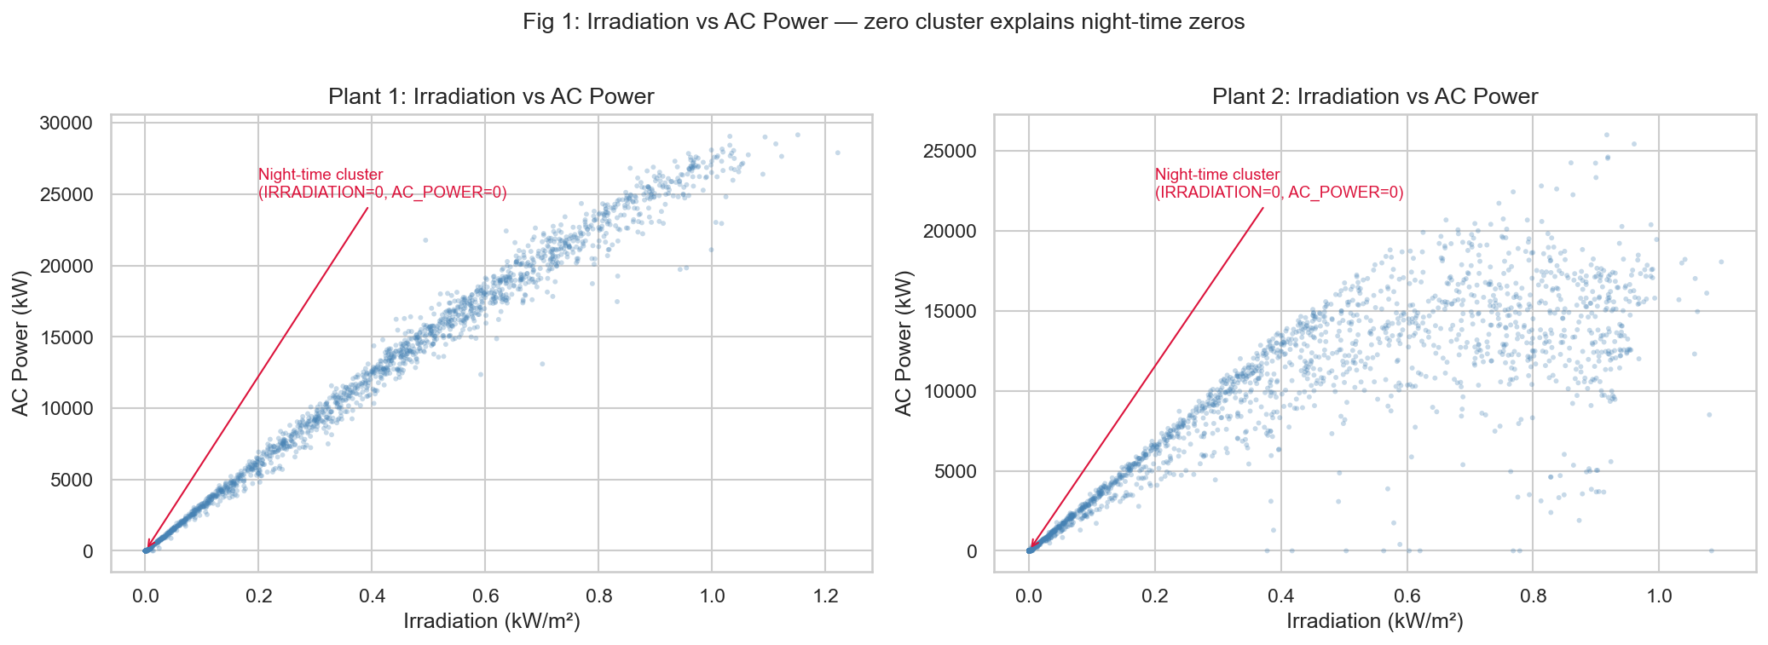
Figure 1: Irradiation vs AC Power — Plant 1 (left) and Plant 2 (right). The night-time cluster at the origin confirms IRRADIATION = 0 ⇔ AC_POWER = 0 for all observations.
Fig. 2 shows the typical day/night cycle of power in a three-day slice. The AC power increases drastically with dawn, reaches its peak in the midday, and goes back to zero in the night, and this is in line with the highest solar irradiation. This period is the motivation of incorporating cyclic time encodings as model features.
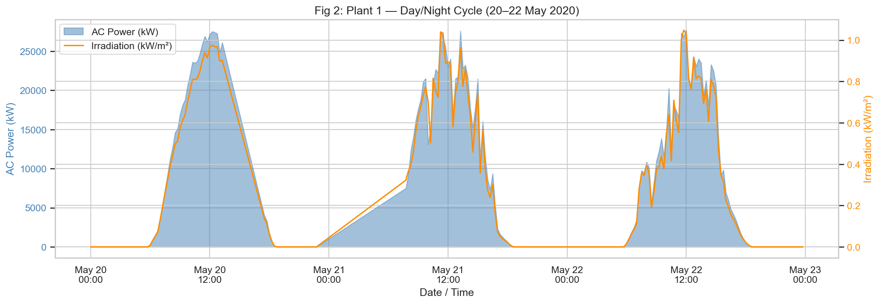
Figure 2: Day/Night AC Power Cycle (3-day window, Plant 1, 20–22 May 2020).
The entire Pearson correlation is represented in figure 3. The positive correlations between ACPOWER and IRRADIATION are very strong between both plants (r = 0.99 Plant 1, r = 0.78 Plant 2). There is an almost perfect result in the correlation of DCPOWER with AC_POWER ( r= 1.00), which makes it be left out in favor of almost non-leakage.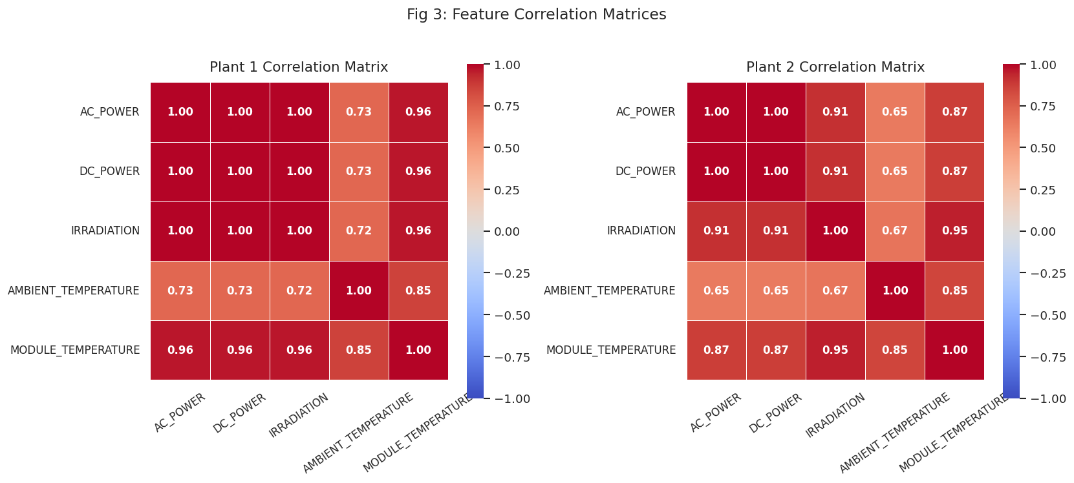
Figure 3: Pearson Correlation Heatmap — Plant 1 (left) and Plant 2 (right). All cells annotated with r values.
Figure 4 illustrates the total AC power throughout the entire study, which was 34 days. Obvious periodic cycles depict daily sunrise/sunset cycles whereas the intermittent dips are on cloudy or overcast days. The two plants are similar in terms of their common time pattern.
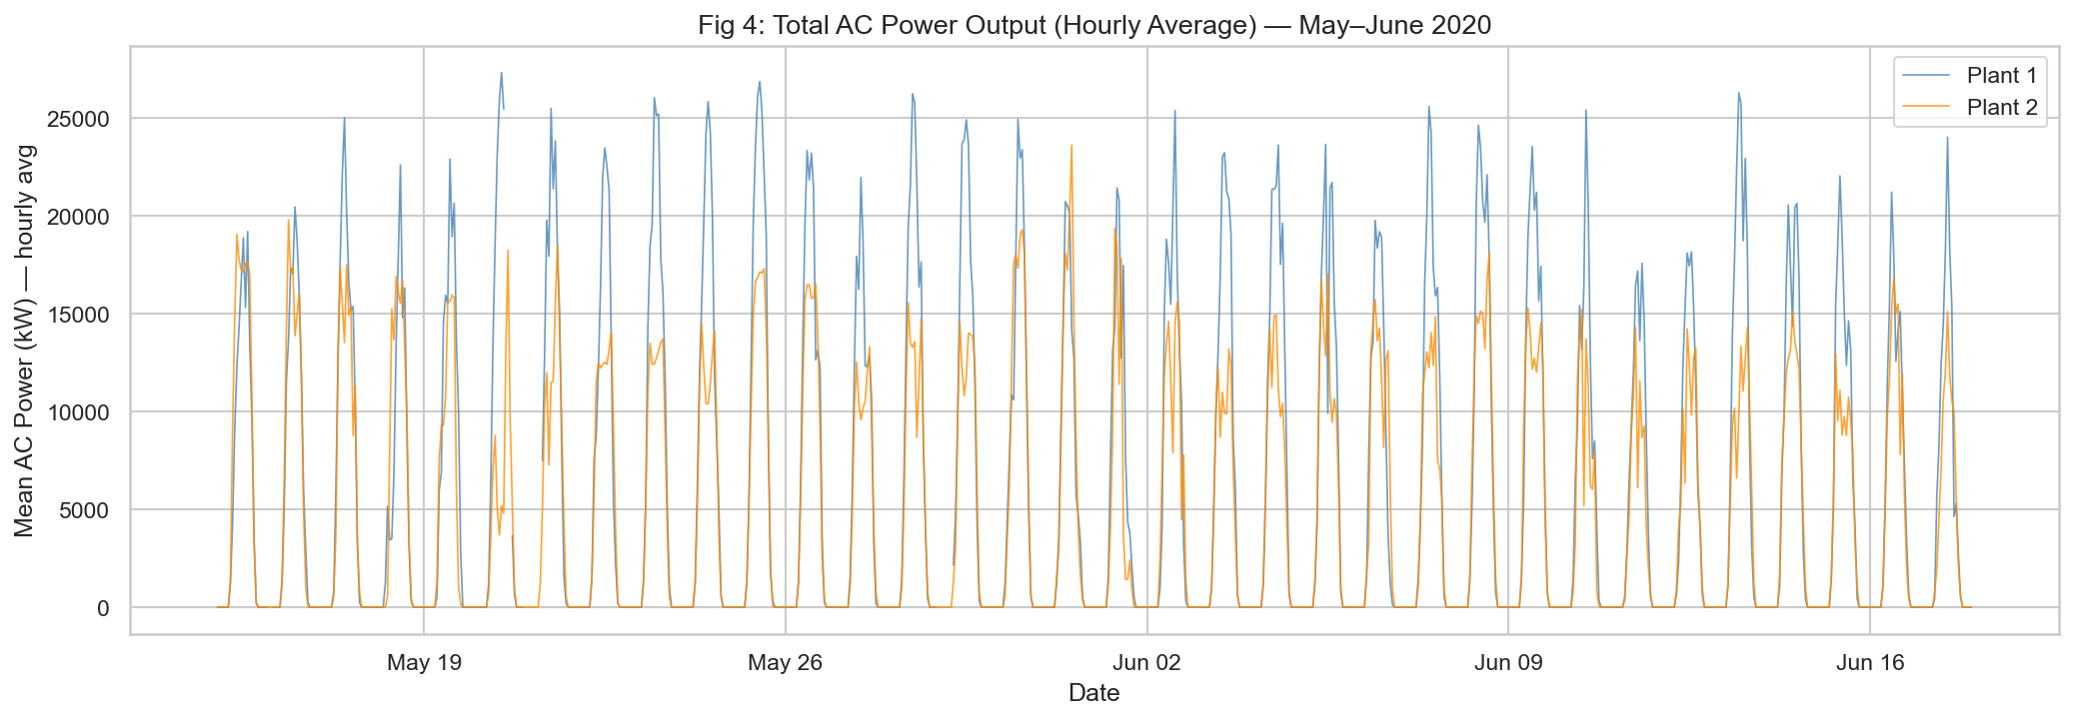
Figure 4: Total AC Power Over the Full Study Period — Plant 1 (blue) and Plant 2 (orange). Hourly resampled averages.

Chapter 4 — Ethical Considerations
Solar Power Generation Data dataset is the study that is publicly available and is downloaded at Kaggle. The variable is the data set of the operational measurement of solar power plants, which is the AC power output, DC power, irradiation and temperature measurements. It does not include any personally identifiable or human subject information and, therefore, does not involve any privacy or confidentiality issue.
Data is used with an academic intent and credit to source has been provided at Kaggle. Hardly any physical location of the plants or the areas that need improvements on the performance is determined since the data is about energy infrastructure and the analysis is constrained on the performance of the models and general trends in the prediction.
All preprocessing, measures of modelling and evaluation are well documented to create research transparency. The code of the analysis will also be provided in the appendix to guarantee the reproducibility of the results.

Chapter 5 — Methodology

5.1 Feature Engineering and Selection
Seven features were selected for modelling based on domain knowledge and EDA correlation analysis. Table 2 summarizes the selected features and their justification.

Table 2: Selected Features and Rationale
Feature | Rationale
IRRADIATION | Primary physical driver of PV energy conversion
AMBIENT_TEMPERATURE | Affects inverter efficiency and panel performance
MODULE_TEMPERATURE | Directly modulates PV cell voltage and current
HOUR_SIN, HOUR_COS | Cyclic encoding of time-of-day (24-hour cycle)
DOY_SIN, DOY_COS | Cyclic encoding of day-of-year (seasonal variation)

DC_POWER was deliberately excluded. Its near-perfect correlation with AC_POWER (r ≈ 1.00) constitutes near-leakage — incorporating it would trivialize the prediction task and render the model non-operational in practice, since DC power is not typically available as a forecast input.

5.2 Task Definition — Prediction vs Forecasting
A significant clarification has to do with the character of the prediction exercise. Since the model is based on the modern irradiation measurements which are recorded at the same 15 minutes as the target AC power, instead of forecasting the weather variables in the future, the task could be better defined as a short-term power prediction (nowcasting) instead of a long-term forecast. This difference applies to operational deployment: in an actual system, the irradiation needs to be itself predicted with numerical weather prediction (NWP) models, which is another source of error. The findings discussed in this work are an upper limit on the accuracy that can be obtained in the ideal case of irradiation knowledge.

5.3 Train/Test Split
An 80/20 split based on time was used on chronologically ordered data of Plant 1. 80 percent constitute the training set, and the remaining 20 percent constitute the held-out test set. This method is very strict about data leakage. To avoid temporal loss, random shuffling was avoided specifically. The split boundary is visualized in figure 5.
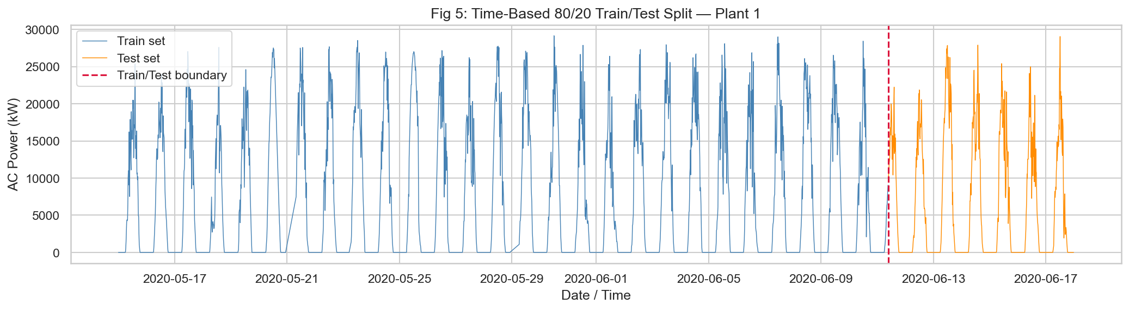
Figure 5: Time-Based 80/20 Train/Test Split (Plant 1). Blue = training period; orange = held-out test period. Red dashed line = split boundary.

5.4 Model 1 — Random Forest Regressor with GridSearchCV
Random Forest Regressor was trained on a Grid search used as a cross-validation strategy, TimeSeriesSplit (5 folds), so that each fold of cross-validation occurs strictly later in time than the corresponding training fold. The grid of hyperparametric search included 81 combinations of parameters multiplied by 5 CV folds = 405 summative model fits. Scoring was based on neg root mean squared error as per the ultimate evaluation measure. The configuration that was found to be the best was the following: n estimators = 300, max depth = None (trees fully grown), min samples split = 2, min samples leaf = 2.

5.5 Model 2 — LSTM Network
A LSTM network (model name: LSTMSolarPower) was created with the help of the TensorFlow/Keras. Sequential context is inputted as a sliding window of 96-time steps (24 hours of 15-minute resolution). The network consists of two LSTM layers (64 and 32 units respectively) each preceded by two Dropout regularization layers (0.2) followed by a non-linear feature compression by an intermediate Dense(16) layer and a final Dense(1) final layer. Adam optimizer reduces the MSE loss. Premature termination (patience = 10 epochs, monitor = valloss) helps to avoid overfitting, and training is stopped in 100 epochs, batch size= 64 and 15 global of the training data used to monitor validation. Scaling of features and target were performed independently with MinMaxScaler that was fitted to only training data; the inverse-transform of the prediction was made and returned to original kW units.

5.6 Baseline and Evaluation Metrics
An innocent baseline - making predictions of the training-set mean AC power of all test samples - provides a performance floor. Each of the models is tested on the same held-out test period using three complementary measures: Root Mean Squared Error (RMSE, kW) which punishes large errors in an unfair manner; Mean Absolute Error (MAE, kW) which gives a strong average error; and Coefficient of Determination (R²) which determines the percentage of variance accounted.

Chapter 6 — Results

6.1 Random Forest — Test Set Performance
The same held out 20% test set is used in Table 3 to introduce performance metrics of all the models. Random Forest model describes 99.57 percent of variance of the test-set AC power output, and RMSE equals, 521.50 kW, which is improvement of 93.5 percent over the baseline RMSE of 7,983.70 kW. The best-modeled ones are marked with bold values.

Table 3: Model Performance Comparison — Plant 1 Held-Out Test Set (20%)
Model | RMSE (kW) | MAE (kW) | R² | Dataset
Baseline (Train Mean) | 7,983.70 | 7,122.67 | -0.0044 | Plant 1
Random Forest (GridSearchCV) | 521.50 | 245.95 | 0.9957 | Plant 1
LSTM | 2,333.42 | 1,291.49 | 0.9183 | Plant 1
RF Generalisation | 2,834.86 | 1,020.57 | 0.7359 | Plant 2

Figure 6 indicates actual-versus-predicted (left) and residual plot (right). The scatter is close to the perfect-prediction diagonal throughout the entire range of power. There is no systematic trend of residuals centered round zero and confirming an unbiased model with homoscedastic error structure.
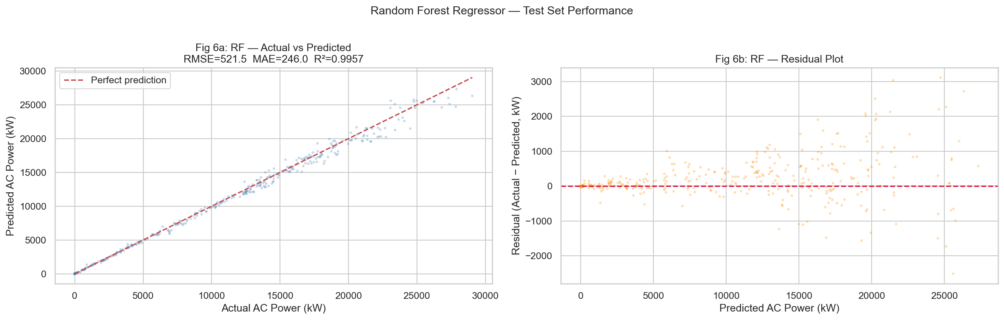
Figure 6: Random Forest — Actual vs Predicted AC Power scatter (left) and Residual Plot (right) on the held-out test set.
Figure 8 represents the comparison of time-series of the first five days of the test period. The Random Forest can follow actual AC power with a high degree of fidelity to both follow the steep increases and decreases at dawn and dusk and follow the intra-day variation accurately.
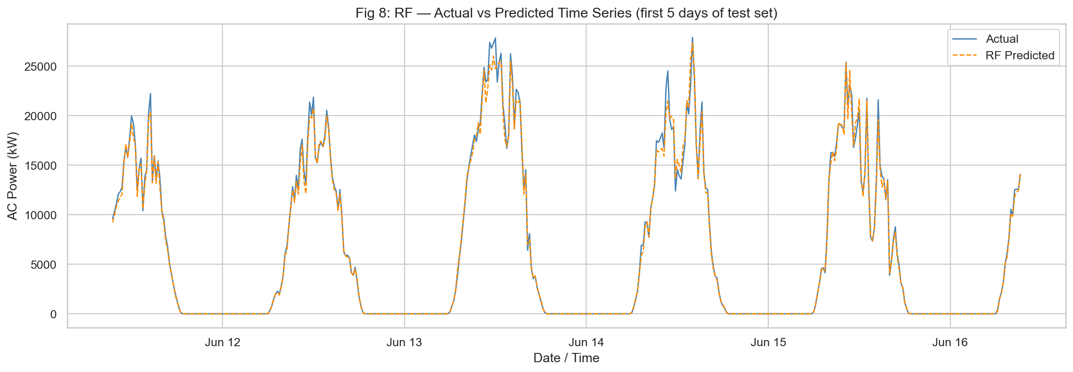
Figure 8: Random Forest — Actual (blue) vs Predicted (orange dashed) AC Power Time Series, first 5 days of the test set.

6.2 Feature Importance
Figure 7 gives impurity-based (Gini) feature importance of the trained Random Forest. Figure 7b shows permutation importance - a more serious measure that measures the degradation of model R² when the values of each feature are randomly shuffled, averaging over 10 repetitions. Error bars indicate standard deviation in repeats of the shuffles. Both the analysis suggests that IRRADIATION is by far dominant.
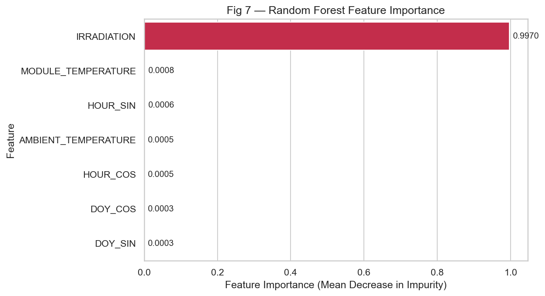
Figure 7: Random Forest — Impurity-Based (Gini) Feature Importance. Values sum to 1.0. IRRADIATION accounts for over 95% of total impurity reduction.
The permutation importance analysis shows that the most important predictor of AC power generation is the solar irradiation with an average importance score that is around 200 times higher than the other predictors. This is in line with the photovoltaic physics: P = e x A x G, where is the conversion efficiency, A is the area of the panel, and G is the irradiance ( W/m 2). Shuffling of irradiation kills this underlying physical connection and results in a radical rise in prediction error.
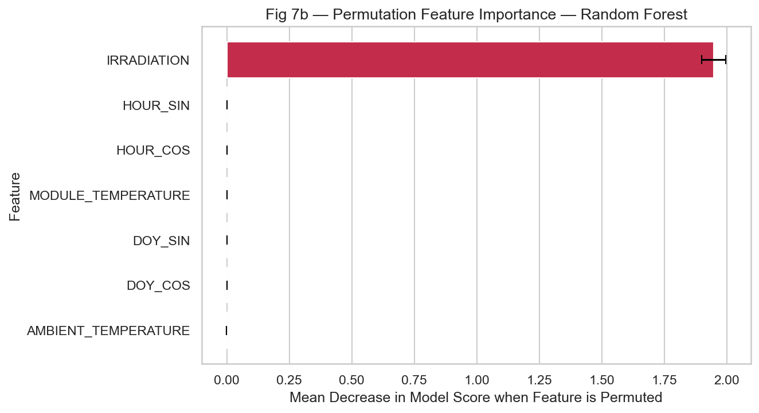
Figure 7b: Permutation Feature Importance — Random Forest. Error bars represent standard deviation across 10 shuffle repeats on the test set.
The cyclic time variables (HOURSIN, HOURCOS, DOYSIN, DOYCOS) are of trivial importance when the amount of irradiation is known known. This comes as no surprise: since the intensity of the sun is a deterministic diurnal variation, irradiation already implicitly records time-of-day. The prevalence of irradiation does not mean that other variables are not important in the real operational forecasting systems. Practical deployments In practical deployments, prediction of irradiation per se must be done with NWP models, and in that case, temperature and temporal characteristics may have a proportionally greater contribution in cases where there is uncertainty in irradiation prediction.

6.3 LSTM — Test Set Performance
On the aligned test set (notably, the initial 96 samples of the test are removed to match the sliding window, as in the notebook implementation), the LSTM network gave R² = 0.9183 with RMSE = 2,333.42 kW and MAE = 1,291.49 kW. Although this is a good absolute performance, it is in many ways worse than the Random Forest. Figure 9 illustrates the training and validation loss curves by LSTM which converges steadily with early termination.
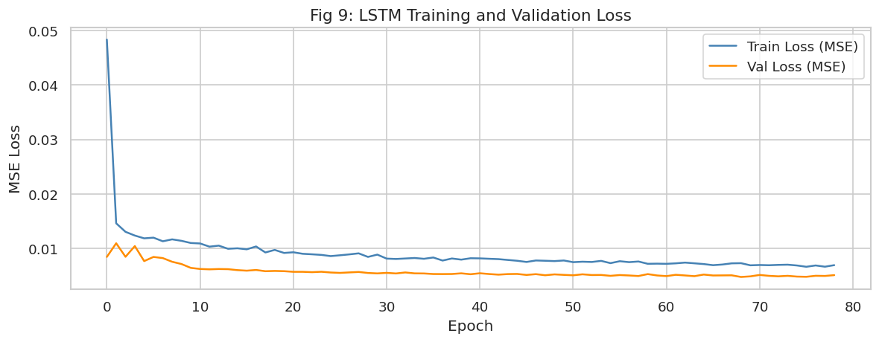
Figure 9: LSTM Training and Validation Loss (MSE) over epochs. Early stopping prevents overfitting by restoring best weights.
Figure 10 illustrates the actual and predicted LSTM of the test set. The LSTM has effectively acquired the overall diurnal cycle but with typical smoothing behavior - it underpredicts severe peaks of production and overpredicts transitions between low-production and high-production states. This is an intrinsic weakness of the gradient-based sequential models using highly variable irradiation profiles.
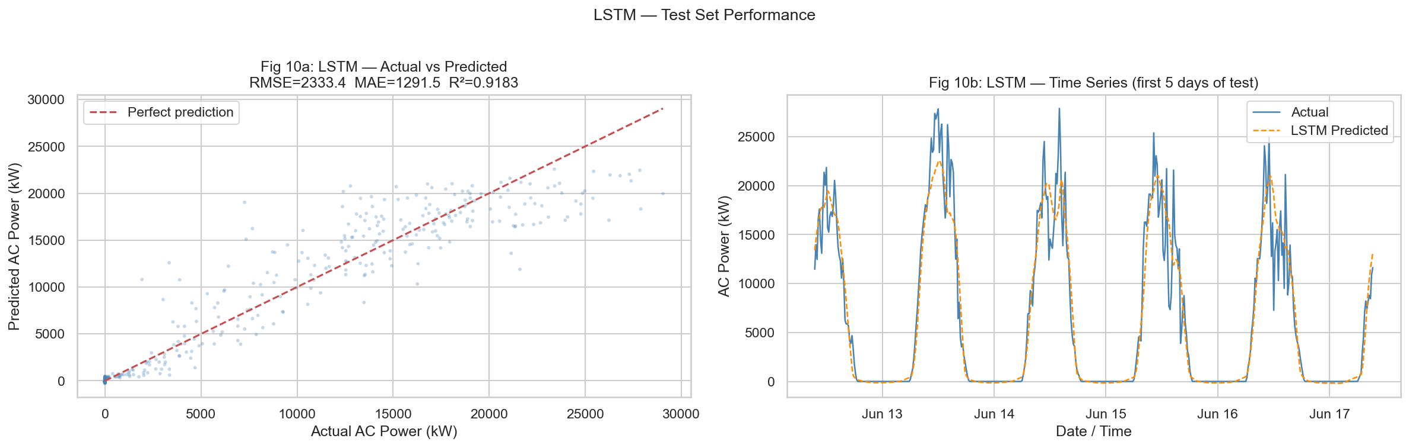
Figure 10: LSTM — Actual vs Predicted AC Power on the Test Set (scatter left, time-series right).

6.4 Model Comparison
The comparison of RMSE, MAE and R² of all the three models is presented in Figure 11. The naive baseline (R² = -0.004) is not predictive. Random Forest and LSTM show significant improvement over it, and it is in all three measures that the best performance is demonstrated by Random Forest by a broad margin.
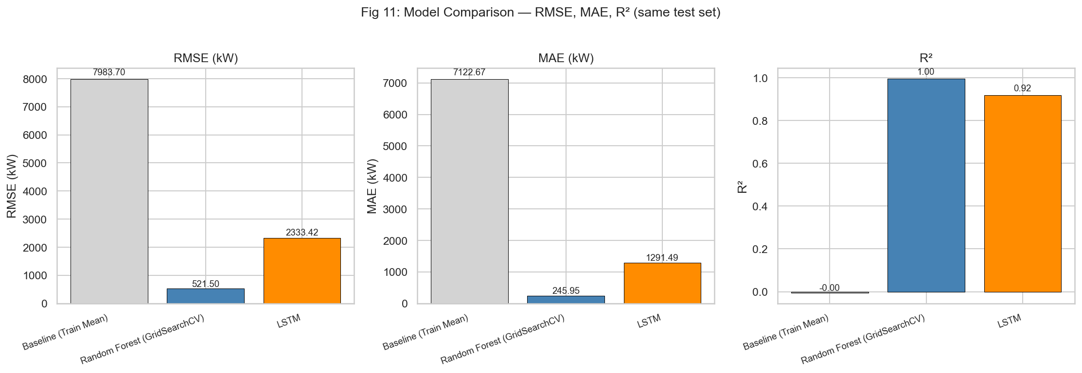
Figure 11: Model Performance Comparison — RMSE (kW), MAE (kW), and R² for Baseline, Random Forest, and LSTM.

6.5 Generalisation to Plant 2
The optimal Random Forest model (trained on only Plant 1) was used on the 20 percent test on Plant 2 without retraining, giving RMSE = 2,834.86 kW and R 2 = 0.7359. Although the absolute RMSE is greater, to indicate variations between sites in installed capacity, inverter properties, and environmental factors, an R 2 greater than 0.73 indicates that the model has learnt relationships and relationships that can be physically transferred between PV installations of the same type.

Chapter 7 — Analysis and Discussion

7.1 Why Random Forest Outperformed LSTM
Random Forest model was significantly better than LSTM in all measures. This is due to several reasons. The overwhelming predictor, which is irradiation, first, is nearly deterministic about AC power at any point in time, and thus models that leverage strong instant correlations of features tend to work better. Random Forest simply models this mapping without any time-dependent information that LSTM is meant to exploit.
Second, the dataset is restricted to 34 days and thus LSTM has limited sequential history to utilize. Multi-year datasets with high long-range temporal structures are best recommend LSTM architectures. Third, the cyclic time characteristics (HOUR_SIN/COS) are directly encoded into the Random Forest, since it is unable to represent sequential state. Lastly, in the case of the Random Forest, the gridSearchCV gave it a systematically optimized configuration, whilst the LSTM did not receive a similar architecture search.

7.2 Irradiation as Dominant Predictor
Importance analysis based on impurity as well as permutation assures that IRRADIATION dictates model predictions. This is in line with the physical principle that the main input in the PV energy conversion process is solar irradiance. The permutation analysis is also more rigorous and measures the increase in out-of-sample prediction error directly when a feature is omitted - an otherwise model-agnostic measure of relevance with no high-cardinality bias in impurity importance.

7.3 Limitations
Poor time coverage: The 34-day data set fails to represent seasonal change, and this may considerably influence the model generalization at other times of the year or when meteorological regimes differ.
Forecasting instead of nowcasting: The models are fitted using known irradiation at the prediction time instead of a prediction of the irradiation in the future. It would need to be incorporated with NWP forecasts to become operational.
Sensitivities to LSTM architecture: LSTM models are sensitive to the level of sequence length, batch size, learning rate and layer depth. The existing architecture (64 -32 LSTM units) was not searched in the same way as the Random Forest.
Single-site training: This is the major model that is trained in Plant 1. The cross-plant generalization (R² = 0.74 on Plant 2) indicates that retraining specific to the site would further enhance the performance of the operations.

7.4 Future Work
Weather forecast integration: Adding NWP irradiation forecasts as inputs to the model to have the capability to predict the actual ahead-of-time power operation.
Convolutional Transformer: Learners Input Learners can now incorporate multi-horizon forecast ability into their attention mechanisms through Temporal Fusion Transformer or PatchTST models.
Multi-site pooling: Educating using multiple PV plants of data to enhance generalization and give regional grid scale production estimates.
Hyperparameter search in LSTM: A Bayesian optimization on LSTM architecture parameters to find competitive configurations with the Random Forest benchmark.

Chapter 8 — Reproducibility
Python 3.10 was used to perform all experiments with NumPy and TensorFlow having their random seeds fixed (RANDOM_SEED= 42). All preprocessing code, model training code and figure-generating scripts can be found in Appendix C. The notebook Solar energy production final code v 2 resubmission.ipynb can be run sequentially through Cell 0 to cell 52 to recreate all the results and figures of this work. The Kaggle Solar Power Generation Data contains datasets (Final_Merged_Plant_1.csv and Final_Merged_Plant_2.csv). All model measures are stored programmatically to model_metrics.csv and best RF parameters to rf_best_params.json to make sure it is verifiable.

Chapter 9 — Conclusion
The paper has shown that machine learning models are sufficient to forecast the solar power output under photovoltaic installations at present using the latest meteorological characteristics. The optimized Random Forest Regressor (optimized by timeseries Split with a gridSearchCV) took R² = 0.9957 on the held-out test set - significantly better than the LSTM (R² = 0.9183) and the naive mean baseline (R² = -0.004).
Analysis of the permutation importance validated the fact that solar irradiation is the by far dominant predictor which is expected of PV physics. The prediction exercise is better described as nowcasting, that is, it uses known contemporaneous irradiation and not what is yet to come, and model accuracy is thus an upper bound in idealized circumstances. The R² on Plant 2 using cross-plant generalization is 0.74, which validates the existence of a strong physical meaning of the learned feature-target relationship and transferability.
Such observations are in line with the literature that the ensemble tree-based approaches have been shown to be better in situations where the correlation between features and targets are high and the dataset is small compared to the deep sequential architectures. Further developments in this area should be on combining NWP irradiation forecasts and experimenting with Transformer-based architectures when performing real multi-step-ahead operational forecasting.

References
Ahmed, R. et al. (2020) “A review and evaluation of the state-of-the-art in PV solar power forecasting: Techniques and optimization,” Renewable and Sustainable Energy Reviews, 124, p. 109792. Available at: https://doi.org/10.1016/j.rser.2020.109792.

Antonanzas, J. et al. (2016) “Review of photovoltaic power forecasting,” Solar Energy, 136, pp. 78–111. Available at: https://doi.org/10.1016/j.solener.2016.06.069.

Breiman, L. (2001) “Random forests,” Machine Learning, 45(1), pp. 5–32. Available at: https://doi.org/10.1023/A:1010933404324.

Hochreiter, S. and Schmidhuber, J. (1997) “Long Short-Term Memory,” Neural Computation, 9(8), pp. 1735–1780. Available at: https://doi.org/10.1162/neco.1997.9.8.1735.

Solar Power Generation Data (no date). Available at: https://www.kaggle.com/datasets/anikannal/solar-power-generation-data (Accessed: March 6, 2026).

Voyant, C. et al. (2017) “Machine learning methods for solar radiation forecasting: A review,” Renewable Energy, 105, pp. 569–582. Available at: https://doi.org/10.1016/j.renene.2016.12.095.

Wan, C. et al. (2015) “Photovoltaic and solar power forecasting for smart grid energy management,” CSEE Journal of Power and Energy Systems, 1(4), pp. 38–46. Available at: https://doi.org/10.17775/cseejpes.2015.00046.

Appendix A — Random Forest Hyperparameter Grid
The following table documents the full GridSearchCV search space alongside the best values identified. The CV strategy was Timeseries Split with 5 folds; scoring used neg_root_mean_squared_error. Total fits = 81 combinations × 5 folds = 405.

Table A1: GridSearchCV Hyperparameter Search Space and Best Configuration
Hyperparameter | Search Values | Best Value
n_estimators | [100, 200, 300] | 300
max_depth | [None, 10, 20] | None (fully grown trees)
min_samples_split | [2, 5, 10] | 2
min_samples_leaf | [1, 2, 4] | 2
CV strategy | TimeSeriesSplit(n_splits=5) | —
Scoring metric | neg_root_mean_squared_error | —
Total CV fits | 81 × 5 = 405 | —
Best CV RMSE | — | Reported in notebook output

Appendix B — Python Environment
All experiments were run with the following package versions. Exact reproducibility requires matching these versions.
Python 3.10
numpy 1.24
pandas 2.0
matplotlib 3.7
seaborn 0.12
scikit-learn 1.3
tensorflow 2.13
keras 2.13
scipy 1.11
jupyter 1.0

Appendix C — Core Notebook Code
The following code is extracted verbatim from Solar_energy_production_final_code_v2_resubmission.ipynb. Execute cells top-to-bottom with RANDOM_SEED = 42 to reproduce all results.

C.1 — Imports and Configuration (Cell 2)
import warnings
warnings.filterwarnings('ignore')

import numpy as np
import pandas as pd
import matplotlib
import matplotlib.pyplot as plt
import matplotlib.dates as mdates
import seaborn as sns

from sklearn.ensemble import RandomForestRegressor
from sklearn.model_selection import GridSearchCV, TimeSeriesSplit
from sklearn.preprocessing import MinMaxScaler
from sklearn.metrics import mean_squared_error, mean_absolute_error, r2_score
from sklearn.inspection import permutation_importance

import tensorflow as tf
from tensorflow.keras.models import Sequential
from tensorflow.keras.layers import LSTM, Dense, Dropout
from tensorflow.keras.callbacks import EarlyStopping

# ── Reproducibility ─────────────────────────────────────────────────
RANDOM_SEED = 42
np.random.seed(RANDOM_SEED)
tf.random.set_seed(RANDOM_SEED)

# ── File paths ──────────────────────────────────────────────────────
PLANT1_PATH = 'Final_Merged_Plant_1.csv'
PLANT2_PATH = 'Final_Merged_Plant_2.csv'

C.2 — Preprocessing Pipeline (Cell 6)
def preprocess_plant(df, plant_label):
"""Full preprocessing pipeline for a single plant's raw inverter-level data."""
df = df.copy()
df['DATE_TIME'] = pd.to_datetime(df['DATE_TIME'])
df.sort_values(['DATE_TIME', 'SOURCE_KEY'], inplace=True)
df.reset_index(drop=True, inplace=True)
df.drop_duplicates(inplace=True)
# Time-based interpolation within each inverter group
numeric_cols = df.select_dtypes(include=np.number).columns
df[numeric_cols] = df.groupby('SOURCE_KEY')[numeric_cols]\
.transform(lambda g: g.interpolate(method='time'))
df = df.dropna(subset=['AC_POWER'])
# Aggregate to one record per timestamp
agg = df.groupby('DATE_TIME').agg(
AC_POWER=('AC_POWER', 'sum'),
DC_POWER=('DC_POWER', 'sum'),
IRRADIATION=('IRRADIATION', 'mean'),
AMBIENT_TEMPERATURE=('AMBIENT_TEMPERATURE', 'mean'),
MODULE_TEMPERATURE=('MODULE_TEMPERATURE', 'mean')
).reset_index()
assert agg.isnull().sum().sum() == 0, "Missing values remain after preprocessing!"
# Cyclic time features
agg['HOUR'] = agg['DATE_TIME'].dt.hour
agg['DAY_OF_YEAR'] = agg['DATE_TIME'].dt.dayofyear
agg['HOUR_SIN'] = np.sin(2 * np.pi * agg['HOUR'] / 24)
agg['HOUR_COS'] = np.cos(2 * np.pi * agg['HOUR'] / 24)
agg['DOY_SIN'] = np.sin(2 * np.pi * agg['DAY_OF_YEAR'] / 365)
agg['DOY_COS'] = np.cos(2 * np.pi * agg['DAY_OF_YEAR'] / 365)
return agg

print('Processing Plant 1...')
plant1 = preprocess_plant(plant1_raw, 'Plant 1')
print('Processing Plant 2...')
plant2 = preprocess_plant(plant2_raw, 'Plant 2')

C.3 — Feature Selection (Cell 20)
FEATURES = [
'IRRADIATION',
'AMBIENT_TEMPERATURE',
'MODULE_TEMPERATURE',
'HOUR_SIN', 'HOUR_COS',
'DOY_SIN', 'DOY_COS',
]
TARGET = 'AC_POWER'

df_model = plant1[['DATE_TIME'] + FEATURES + [TARGET]].copy()
df_model.sort_values('DATE_TIME', inplace=True)
df_model.reset_index(drop=True, inplace=True)

C.4 — Train/Test Split (Cells 22–23)
N = len(df_model)
SPLIT_IDX = int(N * 0.80)
train_df = df_model.iloc[:SPLIT_IDX]
test_df = df_model.iloc[SPLIT_IDX:]
X_train = train_df[FEATURES].values
y_train = train_df[TARGET].values
X_test = test_df[FEATURES].values
y_test = test_df[TARGET].values
print(f'Total samples : {N}')
print(f'Train samples : {len(train_df)}')
print(f'Test samples : {len(test_df)}')
print('\n\u2713 No data leakage: test set is strictly after training set.')

C.5 — GridSearchCV — Random Forest (Cells 25–26)
tscv = TimeSeriesSplit(n_splits=5)
param_grid = {
'n_estimators': [100, 200, 300],
'max_depth': [None, 10, 20],
'min_samples_split': [2, 5, 10],
'min_samples_leaf': [1, 2, 4],
}
rf_base = RandomForestRegressor(random_state=RANDOM_SEED, n_jobs=-1)
grid_search = GridSearchCV(
estimator=rf_base,
param_grid=param_grid,
cv=tscv,
scoring='neg_root_mean_squared_error',
n_jobs=-1,
verbose=1,
refit=True
)
print('Running GridSearchCV (this may take a few minutes)...')
grid_search.fit(X_train, y_train)
print(f'Best CV RMSE : {-grid_search.best_score_:.4f} kW')
print(f'Best params : {grid_search.best_params_}')
rf_best = grid_search.best_estimator_

C.6 — LSTM Architecture (Cells 36–39) — Exact Notebook Architecture
WINDOW_SIZE = 96 # 24 hours of 15-min intervals
BATCH_SIZE = 64
MAX_EPOCHS = 100
PATIENCE = 10

# ── Scale features & target independently ──────────────────────────────
scaler_X = MinMaxScaler()
scaler_y = MinMaxScaler()
X_train_sc = scaler_X.fit_transform(X_train) # fit on train only
X_test_sc = scaler_X.transform(X_test)
y_train_sc = scaler_y.fit_transform(y_train.reshape(-1, 1)).ravel()
y_test_sc = scaler_y.transform(y_test.reshape(-1, 1)).ravel()

def make_sequences(X, y, window):
"""Create sliding window sequences for LSTM input."""
Xs, ys = [], []
for i in range(window, len(X)):
Xs.append(X[i - window:i])
ys.append(y[i])
return np.array(Xs), np.array(ys)

X_train_seq, y_train_seq = make_sequences(X_train_sc, y_train_sc, WINDOW_SIZE)
X_test_seq, y_test_seq = make_sequences(X_test_sc, y_test_sc, WINDOW_SIZE)

# ── Build LSTM model ────────────────────────────────────────────────────
n_features = X_train_seq.shape[2]

model_lstm = Sequential([
LSTM(64, return_sequences=True, input_shape=(WINDOW_SIZE, n_features)),
Dropout(0.2),
LSTM(32, return_sequences=False),
Dropout(0.2),
Dense(16, activation='relu'),
Dense(1)
], name='LSTM_SolarPower')
model_lstm.compile(optimizer='adam', loss='mse')
model_lstm.summary()

early_stop = EarlyStopping(
monitor='val_loss',
patience=PATIENCE,
restore_best_weights=True,
verbose=1
)

history = model_lstm.fit(
X_train_seq, y_train_seq,
validation_split=0.15, # 15% of train used for validation
epochs=MAX_EPOCHS,
batch_size=BATCH_SIZE,
callbacks=[early_stop],
verbose=1
)

C.7 — LSTM Predictions and Metrics (Cell 41)
y_pred_lstm_sc = model_lstm.predict(X_test_seq, verbose=0).ravel()
y_pred_lstm = scaler_y.inverse_transform(y_pred_lstm_sc.reshape(-1, 1)).ravel()

# Align y_test: skip first WINDOW_SIZE rows (matches sequence window)
y_test_lstm = y_test[WINDOW_SIZE:]

rmse_lstm = np.sqrt(mean_squared_error(y_test_lstm, y_pred_lstm))
mae_lstm = mean_absolute_error(y_test_lstm, y_pred_lstm)
r2_lstm = r2_score(y_test_lstm, y_pred_lstm)
print(f' RMSE : {rmse_lstm:.4f} kW')
print(f' MAE : {mae_lstm:.4f} kW')
print(f' R2 : {r2_lstm:.4f}')

C.8 — Save Results (Cell 51)
metrics_df = pd.DataFrame({
'Model': ['Baseline', 'Random Forest (Plant1 test)',
'LSTM (Plant1 test)', 'RF Generalisation (Plant2 test)'],
'RMSE_kW': [rmse_base, rmse_rf, rmse_lstm, rmse_p2],
'MAE_kW': [mae_base, mae_rf, mae_lstm, mae_p2],
'R2': [r2_base, r2_rf, r2_lstm, r2_p2],
})
metrics_df.to_csv('model_metrics.csv', index=False)

import json
best_params = grid_search.best_params_.copy()
with open('rf_best_params.json', 'w') as f:
json.dump(best_params, f, indent=2, default=str)

